Birds of Prey and how to cope.

Sparrowhawk

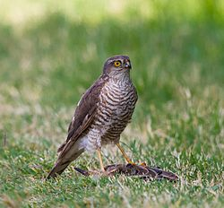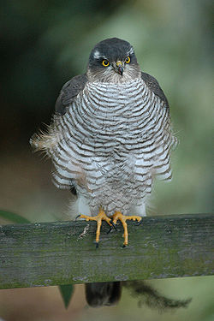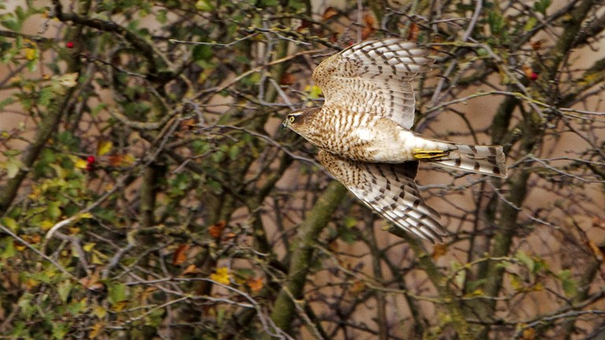

Female capturing Starling Male
The Eurasian Sparrow hawk also known as the Northern Sparrow hawk or simply the Sparrow hawk, is a small bird of prey in the family Accipitridae. Adult male Eurasian Sparrow hawks have bluish grey upperparts and orange-barred underparts; females and juveniles are brown above with brown barring below. The female is up to 25% larger than the male – one of the largest differences between the sexes in any bird species. Though it is a predator which specialises in catching woodland birds, the Eurasian Sparrow hawk can be found in any habitat and often hunts garden birds in towns and cities. Males tend to take smaller birds, including tits, finches, and sparrows; females catch primarily thrushes and starlings, but are capable of killing birds weighing 500 grams (18 oz) or more.
The Eurasian Sparrow hawk is found throughout the temperate and subtropical parts of the Old World; while birds from the northern parts of the range migrate south for winter, their southern counterparts remain resident or make dispersive movements. Eurasian Sparrow hawks breed in suitable woodland of any type, with the nest, measuring up to 60 cm (2.0 ft) across, built using twigs in a tree. Four or five pale blue, brown-spotted eggs are laid; the success of the breeding attempt is dependent on the female maintaining a high weight while the male brings her food. The chicks hatch after 33 days and fledge after 24 to 28 days.
The probability of a juvenile surviving its first year is 34%, with 69% of adults surviving from one year to the next. Mortality in young males is greater than that of young females and the typical lifespan is four years. This species is now one of the commonest birds of prey in Europe, although the population crashed after the Second World War. Organochlorine insecticides used to treat seeds before sowing built up in the bird population and the concentrations in Eurasian Sparrow hawks were enough to kill some outright and incapacitate others; affected birds laid eggs with fragile shells which broke during incubation. However, its population recovered after the chemicals were banned, and it is now relatively common, classified as being of Least Concern by BirdLife International.

The Eurasian Sparrowhawk's hunting behaviour has brought it into conflict with humans for hundreds of years, particularly racing pigeon owners and people rearing poultry and gamebirds. It has also been blamed for decreases in passerine populations; scientific research has found no link between increased numbers of Eurasian Sparrowhawks and declines in some farmland and woodland birds after World War II. Studies of racing pigeon deaths found that Eurasian Sparrowhawks were responsible for less than 1%. Falconers have utilised the Eurasian Sparrowhawk since at least the 16th century; although the species has a reputation for being difficult to train, it is also praised for its courage.
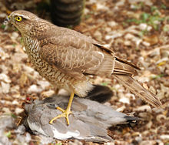
A juvenile with a kill. Larger birds such as Common Wood Pigeons are more often killed by the larger female Eurasian Sparrowhawks; males usually hunt smaller prey.
The Eurasian Sparrowhawk is a small bird of prey with short, broad wings and a long tail, both adaptations to manoeuvring through trees. Females can be up to 25% larger than males^{[8]} and weigh up to twice as much.^{[18]} When females are larger than males, it is known as reverse sexual dimorphism; this is unusual in higher vertebrates but typical in birds of prey,^{[19]} and most marked in birds of prey which hunt birds.^{[18]}
The adult male is 29–34 cm (11–13 in) long, with a wingspan of 59–64 cm (23–25 in)^{[8]} and a mass of 110–196 g (3.9–6.9 oz).^{[12]} He has slate-grey upperparts (sometimes tending to bluish), with finely red-barred underparts, which can look plain orange from a distance; his irides are orange-yellow or orange-red. The female is much larger at 35–41 cm (14–16 in) long, with a wingspan of 67–80 cm (26–31 in),^{[8]} and a mass of 185–342 g (6.5–12.1 oz).^{[12]} She has dark brown or greyish-brown upperparts, and brown-barred underparts, and bright yellow to orange irides. The juvenile is warm brown above, with rusty fringes to the upperparts; and coarsely barred or spotted brown below, with pale yellow eyes;^{[15]} its throat has dark streaks and lacks a mesial (midline) stripe.^{[14]}

The peregrine
The peregrine is a large and powerful falcon. It has long, broad, pointed wings and a relatively short tail. It is blue-grey above, with a blackish top of the head and an obvious black 'moustache' that contrasts with its white face. Its breast is finely spotted. It is swift and agile in flight, chasing prey. The strongholds of the breeding birds in the UK are the uplands of the north and west and rocky seacoasts. Peregrines have suffered illegal killing from gamekeepers and landowners, and been a target for egg collectors, but better legal protection and control of pesticides (which indirectly poisoned birds) have helped the population to recover considerably from a low in the 1960s. Some birds, particularly females and juveniles, move away from the uplands in autumn.

Found along rocky seacliffs and the uplands of the UK are both good places in the breeding season. East coast marshes where there are large gatherings of birds can be a good place in the winter. There are Date with nature events across the UK where you can watch the birds during the breeding season.
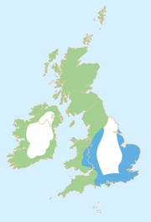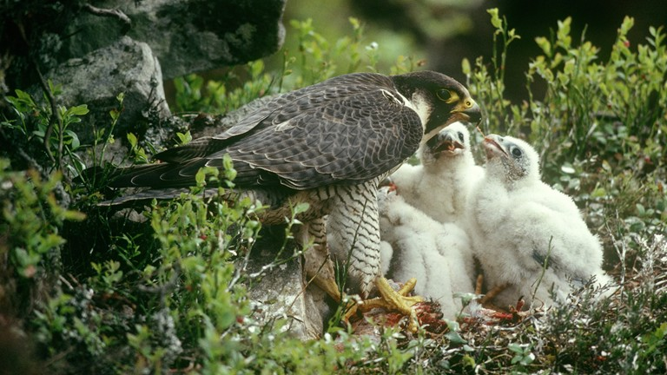

Most of the brooding and feeding of small young is carried out by the female, while the male hunts to supply the food.
Peregrines are territorial, with each territory containing one or more nest sites. The territories are well-spaced, and their size is determined by the abundance of food.
The nest site, known as an eyrie, is usually on a grassy or earthen cliff-ledge, quarry or other inaccessible undisturbed location. Buildings and other constructions are increasingly being used. Old nests of other species such as ravens are used elsewhere in the world, but rarely in the UK.
The nest itself is a slight scrape in earth or old debris on the nest ledge. No material is brought in to build a nest. The female forms the scrape using her chest and legs.
The female normally lays a clutch of three or four eggs in late March or April at 2-3 day intervals. Both birds share the incubation, which begins with the last or penultimate egg, and takes 29-32 days per egg.
The chicks hatch over a period of a couple of days, and have smaller size differences than chicks of most raptor species. Most of the brooding and feeding of small young is carried out by the female, while the male hunts to supply the food. After the first couple of weeks, the female shares the hunting.
The young fledge at 35-42 days, and are independent two or more months later. During this time, the adult peregrines teach the young to hunt and handle prey in flight. Less than a third of peregrines reach breeding age. Those that do can expect to live 5-6 years. The oldest known peregrine was over 16 years old.


This ubiquitous falcon ranges from tropical forests to semi-desert to high Arctic, and from mountains down to sea level.
It requires extensive open terrain for hunting. The precise type of surface habitat is less important than availability of suitable prey.
Suitable nesting sites restrict peregrines to areas where cliff-ledges, quarry faces, crags, or sea-cliffs are available. Recently, they have started to use man-made constructions, especially tall buildings. Tree nesting occurs only rarely in the UK.
The peregrine feeds primarily on birds, which it catches in flight. It spots the prey at distance and, once positioned correctly, it stoops at speeds of up to 180 kph for the catch. To enable the bird to breathe at this speed, it has special baffles in its nostrils, which control breathing.
The high-speed stoop means that the peregrine must catch its prey on the wing to avoid injuring itself on impact. Despite its speed and agility, the peregrine is not always successful – many stoops fail to secure prey. Sometimes, if a surprise attack is possible at lower speeds, it snatches prey from a perch or the ground. Little of the kill is wasted - usually all that is left are the intestines and the breastbone with the feathered wings.
Feral pigeons are favourite prey wherever they are freely available, though a wide range of birds are taken, ranging in size from goldcrest to grey heron. The larger females take larger prey than males. This generalist diet allows peregrines to exist wherever there are good mixed bird populations. They sometimes take mammals, and there are records of occasional amphibians, lizards and large insects.

Legal status

The peregrine is afforded the highest degree of legal protection under Schedule 1 of the Wildlife and Countryside Act 1981.
It is an offence to intentionally take, injure or kill a peregrine or to take, damage or destroy its nest, eggs or young. It is also an offence to intentionally or recklessly disturb the birds close to their nest during the breeding season. Violation of the law can attract fines up to £5,000 per offence and/or a prison sentence of up to six months.
The Nature Conservation (Scotland) Act 2004 widens this protection and provides additional
protection for the peregrine in Scotland. 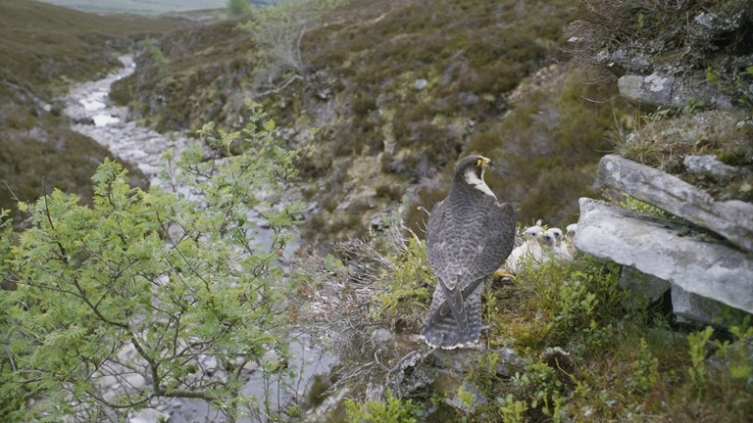
Around 20% of the European peregrine population breeds in the UK and we therefore have an international responsibility to conserve this species.
The RSPB believes that the highest level of protection is essential to the conservation of the peregrine, which remains comparatively rare, and is extremely vulnerable to human activities (including continued illegal persecution). Once the peregrine population declines, it takes many years to recover. The peregrine is a valuable indicator species of the health of the environment, but only if its numbers are not kept artificially low.
RSPB believes some pigeon fanciers and their organisations have called for birds of prey, particularly sparrow hawks and peregrines, to be removed or killed to protect their interests. These calls continue despite the results of scientific studies, which clearly and consistently conclude that removal or lethal control is not justified.
Any change in the law to protect racing pigeons at the expense of protected birds of prey is resisted by the RSPB. There is no scientific justification for suggesting that the killing or removal of birds of prey is an appropriate, proportionate response to this issue.
The RSPB believes that pigeon owners must accept there are some natural risks in the environment into which they choose to deliberately release their birds. Bird of prey impacts on racing pigeons are extremely low when compared to other factors such as straying, bad weather, domestic cats and collisions.
It's always a thrill to see a bird of prey, especially if it's in your own back garden, but sometimes working out what it is can be tricky.
The RSPB's Wildlife Enquiries team probably receives more queries about sparrow hawks than any other species.

Buzzard
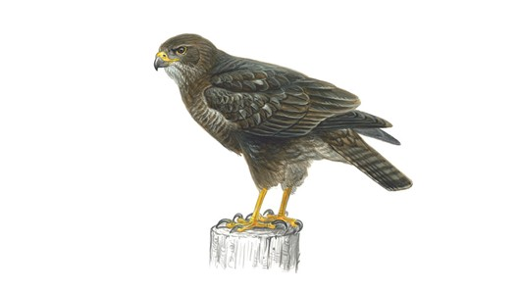
Now the commonest and most widespread UK bird of prey. It is quite large with broad, rounded wings, and a short neck and tail. When gliding and soaring it will often hold its wings in a shallow 'V' and the tail is fanned. Birds are variable in colour from all dark brown to much paler variations, all have dark wingtips and a finely barred tail. Their plaintive mewing call could be mistaken for a cat.

Where to see them
Greatest numbers in Scotland, Wales, the Lake District and SW England, but now breeding in every county of the UK. Found in most habitats particularly woodland, moorland, scrub, pasture, arable, marsh bog and villages. May even be seen in towns and cities including Glasgow. Look for birds soaring over wooded hillsides in fine weather, or perched on fence posts and pylons. In some areas they are known as the tourists’ eagle, often being mistaken for this larger bird of prey.

When to see them
All year round. Birds soar, display and call most in spring.

What they eat
Small mammals, birds and carrion. And even earthworms and large insects when other prey is in short supply.

Uhu (The Largest Eagle Owl)

Many good pigeons have fallen victim to one kind of hawk or another which is a frustrating state of affairs for pigeon fanciers as birds of prey are generally protected. There has been a population explosion of them especially in Germany with its large forested areas and complete protection. What is a fancier to do? Many have given up on this hobby altogether while others let out their birds for exercise only during a few short summer months. How could the situation ever get this bad? Does nature not provide a control of the Goshawk's seemingly unlimited increase in population?
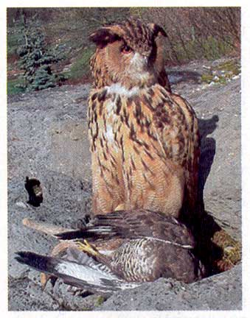
It appears that man is responsible for this imbalance at least in Germany as it was man who exterminated the Uhu (the largest eagle owl) there, the natural enemy of hawks in general. While it is true that this bird would also eat pigeons, given a chance, it hunts at night and is therefore less of a concern for pigeon fanciers than the Goshawk.
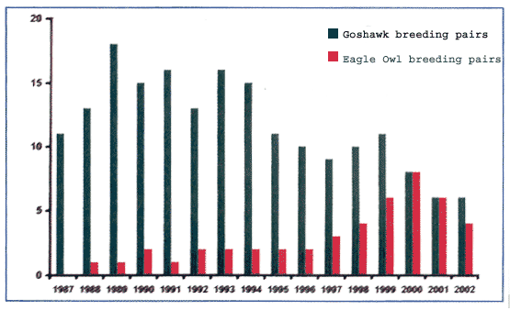
It was in 1987 when this Eagle owl was reintroduced into Schleswig-Holstein. As the number of breeding pairs of this owl increased, the number of Goshawk breeding pairs declined until a steady state was established in 2001.

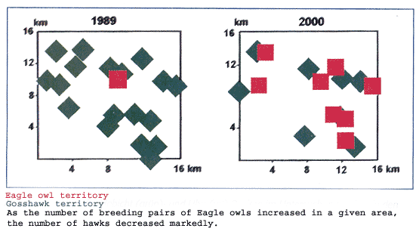
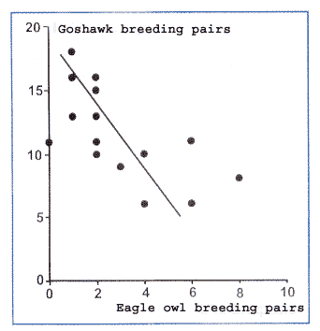
There is an understandable knee jerk reaction after one loses one of one's pigeons, especially if this pigeon showed promise, but I think that it is wiser to temper this anger and try to work with rather than against nature. Remember that it was the extermination of the Eagle owl which caused us racing pigeon fanciers so much grief and I have no doubt that the extermination of another bird of prey, such as the Goshawk, would be just as short sighted.
Original Article at "Die Brieftaube 121 (2004) Nr. 16 | 597"

Some of you, especially those living in areas without a population of Uhus, may look at the above as just a theoretical exercise. However, there is a practical side to it. Fanciers who already considered giving up this beautiful hobby of flying pigeons decided to play a tape with the sounds of this Uhu during periods when they let out their birds for exercise. This resulted in no more losses of pigeons to hawk attacks. If this system would also work in areas where the Uhu is not normally encountered remains to be seen but it would be worth an experiment. it works too, just 30 minutes before letting the birds out is a good idea."this can be down loaded from the internet.
Although I think sparrow hawks will get used to anything especially in winter when food is scarce.

Some fanciers also reported very good results through painting the underside of the wing and the side of the body normally covered by the wing with red ink.
This red flashing is thought to confuse the predator with the result that he pursues other prey in preference. The mechanism with which this is accomplished appears to be similar to the study reported in "Nature".
Early results regarding the playing of Uhu sounds are in: Uhu sounds are just as useless as
- the reflective balland the flashing light.
Many fanciers have better results with the firing of warning shots by using blanks.
Oriental Rollers

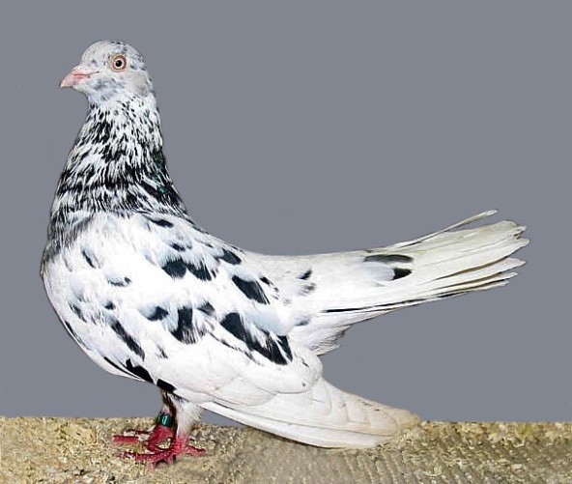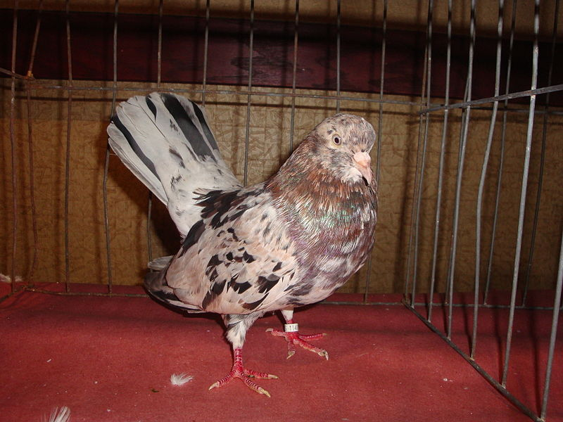

The Oriental Roller is a breed of fancy pigeon developed over many years of selective breeding. Oriental Rollers, along with other varieties of domesticated pigeons are all descendants from the Rock Pigeon.
The key hallmark of the Oriental Roller is its flying style. They show a variety of different figures in the air, which are single somersaults, double somersaults, rolling (a number of uncountable somersaults), rotation with open wings, nose dives, sudden change of direction during flight and very rarely axial turns. Some breeds fly up to 1000 m high, others stay in the air for several hours.
Oriental Rollers were originally bred to avoid desert falcons and had a more varied performance. A fancier had these Oriental Rollers and this was his experience.
A batch of theses Oriental Rollers was release with two hawks visible in the distance. The batch went up and the hawks immediately came in for a visit. The time was now to find out the truth first hand. It was a couple of sharp shins and they made a pass at the batch but the Flying Oriental Rollers darted and dived almost to the ground and evaded the hawks. The hawks made another pass with the same outcome. He was quite pleased. They had performed just as advertised. I started flying the Flying Oriental Rollers every day and had a couple of half hearted attempts until the hawks finally just sit and watched. This pair was evidently migrating because after a week or so of going hungry they moved on. But it is also written that if a hawk does catch one of your mature Flying Oriental Rollers you didn’t need it anyway.
Now he fly two flocks at a time. I always release the Flying Oriental Rollers first to check for hawks and after they trap in I release the second flock in this case Birmingham’s or Galatis. I have twenty one Flying Oriental Rollers so that if I want to fly three or four flocks that day I will only release half at a time. The local hawks will not even attempt to catch the birds now, they just sit off in the distance and watch after so many frustrating unsuccessful attempts at catching the Flying Oriental Rollers. Hawks are intelligent birds and they learn where a meal is will be a good place to come back and look again. They also learn not to waste vast amounts of energy on fruitless chases.
I think I have found the perfect solution for my predator problems.
He will now and forever put up the Flying Oriental Rollers first to train my hawks that they can’t catch my pigeons. He also believe there is a plus to having the hawks chase my Flying Oriental Rollers. I feel that since this is what they were bred for that possibly this will enhance performance.
One word of caution for the first timer with Flying Oriental Rollers. Even though the mature birds are or should be hawk proof the young birds are venerable. It is the diving, spinning and spirals that the birds use to evade hawks and until the young develop these traits they can be caught. Even though I have not lost a bird of any breed since I started this method, when I get an occasional attack it is really quite amusing watching them make their tactical evasion techniques.
He says there is two breeds of Oriental Rollers. One is show type simply named "Oriental Roller" and the other is the genuine "Flying Oriental Roller." You will be best served using the Flying Oriental Roller. keep you entertained as well with their rolling, spinning, diving etc. This is a true performing roller breed.
If you attempt to try this method yourself, you need to understand that there are the Flying Oriental Roller.

How a white feather can outfox a falcon
I came across this article a few years ago and I think it worth a mention.
When aerial menace zooms in from behind, the feral pigeon does what a dove's got to do - it shows the white feather and stands a better chance of getting clean away,
Scientists set out to solve the puzzle of the white patch often found on the rump of the feral pigeon.
In seven years the researchers recorded 1,485 attacks by five adult peregrine falcons on flocks of feral. They also observed 309 attacks by juveniles. They made a note of the plumage of the luckless target.
And they found that whether the peregrines were at the peak of their powers, or still on a learning curve, the result was the same. Only one dead pigeon in 50 had a set of white feathers on its rump.
The scientists reasoned that the white patch might be an evolutionary adaptation that helped its inheritor to live longer and procreate more. Falcons swoop with fearsome speed: the fastest have been clocked at 157 metres a second - around 320mph.
So they tested the idea by capturing 756 white-rumped and blue-grey pigeons and swapping their plumage coloration. They then released the birds again, and monitored the kill rate of three particular peregrines.
Those birds who could no longer show the white feather fell victim to peregrine strike as often as the blue-coloured pigeons, while the newly whitened showed a much increased ability to survive.
No pigeon can out fly a falcon. They escape by aerobatics. The white patch somehow distracts the peregrine.
As more falcons begin to cull the pigeons in modern cities, the scientists argue, an increasing proportion of their prey will start to show the white feather.

Will this be the Pigeon fanciers purple / pink period ?

I know racing pigeons fanciers have dyed their birds with red mark using (sheep dye and food dye) in a effort to distract the hawks when they a attacking the racing pigeon. The following article regarding chicken farmers may be worth giving a go.

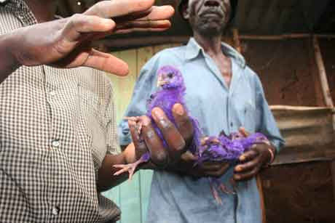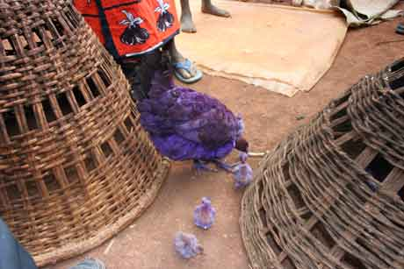

Benson Maniaji shows how chicken-keepers dye their chicks blue which appears to protect them from attack by birds of prey. This farmer innovation was come across by FIPS in Nigeria and introduced to Kenya farmers

FIPS-Africa is working with the Research Into Use Programme (RIU) to develop methodology to empower small-holder farmers to put research into use. FIPSAfrica recruits Village-based Advisors (VBAs) who offer farmers a range of services to assist them increase their crop and livestock productivity. Farmers pay for their services to ensure sustainability of the approach.
Most farmers have a few indigenous chickens, which are left free to scavenge for food around the farm. But in the process, young chicks fall prey to hawks and falcons which take up to 100% of the young chicks within 2 weeks of hatching. VBAs have started to offer farmers a chick dyeing service, which reduces predation to zero.
Combination with vaccination against Newcastle disease greatly increases farmers’ chicken populations which can be sold to pay for seeds of improved crop varieties and fertilizers to improve household food security. VBAs charge farmers KSh 3 for dyeing a chick, which if
it survives to maturity, is worth KSh 300. In assisting farmers to increase their incomes, VBAs also make a profit – up to KSh 250 (ca. US$3) from dyeing 100 chicks. A WIN-WIN situation!

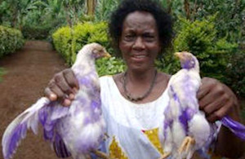
How's this for Easter chicks? Cunning farmers in Tanzania are outwitting hawks by dying their chickens pink and purple.
Farmers in Tanzania, sick of losing their chickens to hungry hawks, have taken drastic, if creative action, thanks to an innovative programme funded by UK aid and a little bit of pink dye.
It all started when farmer Wameiri Mpwanbao, who was losing two chickens a day to hawk attacks, was visited by an advisor from an organization called FIPS-Africa. Over a two-month period, she had lost 36 chickens. In a country like Tanzania, where one in three people live on less than £7 a month, this is a huge loss. Not only this, but her chickens were also dying from a deadly bird disease, called Newcastle disease.
The FIPS-Africa advisor told Wameiri to vaccinate her chickens and use a common antiseptic called Gentian Violet to dye them pink or purple.
"At first I thought it was a joke, but the chicks move about freely within the compound while the hawk is up in the trees, and he has never taken any since I tried it," says Wameiri.
So far this year, FIPS-Africas advisors have helped over 3,700 farmers to increase the number of chickens they own through these simple but clever methods. More chickens mean poor families have more birds to sell, raising money to buy food, or pay school fees. A mature chicken is worth around £3 and dying and vaccination costs only 10p.
FIPS-Africa is supported by the Research Into Use programme, which is funded by UK aid from the governments Department for International Development.

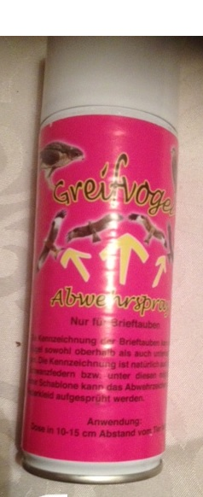
COLOURGUISE
SPRAY REPELLENT FOR RAPTARS
This non toxic Spray is especially for racing pigeons
(The colour is pink as label.)

IT IS NOW AVAILABLE IN IRELAND GREAT BRITTAN AND IT DOES EXACTLY WHAT IT SAYS ON THE TIN.
I was sick of loosing my best young birds and old birds to raptors and been attacked
when training or racing .
This product has been tried and tested in Ireland by experienced fanciers and it does exactly as it says on the thin. Your birds are protected from attack by simply spraying the colour on the pigeons back and shoulders and under the wings.
I found when the my flock of marked racing pigeons were attacked the raptor is confused by the specially formulated colour and quickly looses interest.
Completely safe, non toxic, and water proof, this miracle of modern science will keep your birds protected and give you that racing edge. The colour lasts for 6 month.
For more info call us on +353 8588 55212 or contact us by email at
colourguise@gmail.com facebook

Instructions for spray against raptors ( bird of prey)
OPTION 1
Spray the lower side of the wings and on their backs and shoulders.
(Option1 has been tried in England and Ireland with great results)
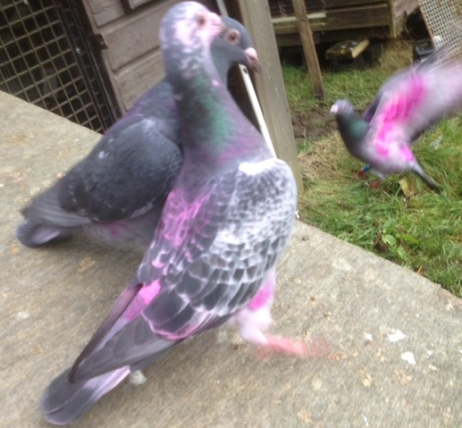
OPTION 2 (The European Method )
Spray on the top of the wings and the lower side of the wings and the tail
(best is to spray with the template on circle on the wings).
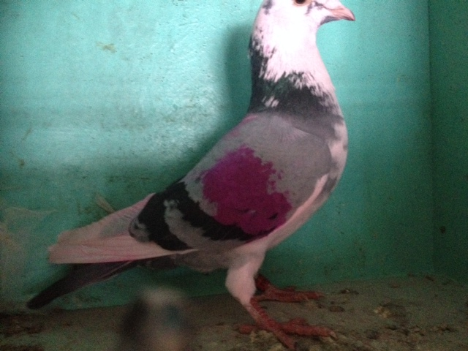

The hawk does not know this circle or colour in nature and will be reluctant to kill your pigeons.

Previous Analysis
Studies, carried out independently, concluded that birds of prey are responsible for only a small proportion of racing pigeon losses relative to other factors, though losses can be greater for owners flying birds in areas with a higher density of peregrines. Authors of these studies recommended that efforts should be made to understand the causes of straying and, in particular, address the way that racing is organised, in order to reduce the risks of flocks clashing. Even if legislation were not in place to protect birds of prey, killing or removing even a small number would not be an appropriate or effective solution. To achieve any noticeable reduction in the number of pigeons lost to birds of prey would require such a large number of peregrines and sparrow hawks to be removed that it would cause serious declines in their UK populations. It is unlikely that even killing of raptors on this scale would make a significant difference to the number of pigeons that return to lofts each year. Conservation groups agree with the UK Raptor Working Group’s rejection of any changes to the legal protection of birds of prey. The working group concluded that there is no legal provision for the licensed control of birds of prey to prevent losses of domestic pigeons.
The way forward
RSPB recognise the genuine concern that some pigeon fanciers have about birds of prey and we are keen to see efforts made to build on the knowledge gained from the recent research. Racing pigeons that are released into the wild face many hazards, natural and unnatural, which are accepted by fanciers as risks of the sport. Attempting to overcome these through
breeding, selection, training and race technique has been a skilled part of pigeon racing since it started in the late 1800s.
The UK Raptor Working Group recommended that greater effort should go into seeking ways to reduce straying and to reduce the vulnerability of pigeons to predators. In particular, it recommended:
_ Priority should be given to reducing straying during races
Specific research was recommended to establish why large numbers of pigeons appear to stray. Once this is better understood and addressed, a large proportion of pigeon losses
could be avoided.
Pigeon fanciers use two different systems of husbandry (a natural system and a widowhood system) to promote a stimulus to return. Research has indicated that pigeons racing on a natural
system are more prone to straying and being taken by peregrines than those on the widowhood system. The group recommended that pigeon racing unions should seriously
consider investigating racing systems in more detail since they have the potential to reduce pigeon losses significantly.
Race routes should be optimised to avoid pigeon flocks clashing
It was recommended that the Homing Unions should work together to optimise and, where
necessary, establish new flight corridors to reduce the complex network of routes currently flown in the UK. These can cause clashing and have the potential to divert pigeons from their race routes.
Pigeon fanciers could reduce the chance of contact with peregrines by establishing more liberation sites in eastern Britain to maximise the routes flown in areas with naturally fewer peregrines.
Race routes in Scotland have already been altered to reduce contact with peregrines.
Consideration should be given to changing the start of the racing season The Group suggested postponing the old bird racing season by five weeks to the end of May to avoid the start of the peregrines’ breeding season. This suggestion was agreeable to some of the fanciers who were asked about its feasibility during the research, and was supported by an article in British Homing World.10 If there are fewer pigeons available to peregrines at the start of the peregrines’ breeding season, they may rear fewer young, so reducing the demand for pigeons throughout the rest of the year.
Loft aspect, exercising and training places should be optimised
The vulnerability of pigeons at the home loft should be investigated by examining the differences in loft aspect and surrounding habitat in relation to the frequency of attack by sparrow hawks. Some lofts experience many fewer attacks than others, which can appear unrelated to sparrow hawk density.
Training tosses should take place in open countryside and away from wooded areas to reduce surprise attack by sparrow hawks, which can cause pigeons to scatter when travel baskets are opened. Varying the times and starting points of exercise flights also makes pigeons a less predictable food source for sparrowhawks and peregrines.
Attempts should be made to reduce raptor attacks at the loft and during training and racing
A full and thorough investigation of the value of deterrents was recommended by the group.
Subsequent trials indicate that wing-transfers and sequins attached to pigeons have little effect, but there has been little evaluation of deterrents around lofts or of conditioned taste aversion, which showed some promise in the 1990s.11Fanciers have little guidance to know which deterrents may be effective, and the most recent study in Scotland6 found that most loft owners had done little to try them. Surprisingly, the techniques perceived by fanciers as the most effective are
deployed by fewer people than techniques regarded as less effective. There remains a real need to evaluate the effectiveness of a range of deterrents, particularly mirrors and reflectors.

Conclusion

I live in the country side with plenty of sparrow hawks and Perkins hunting about. I have lost 2 to3 pigeons in one day to the sparrow hawks.
I generally close my loft from the end of August till April /May due to the sparrow hawk attacks. Mealy ,reds ,blue and blue/ pyds and anything with white goes first to the hawks.
I have found the best time to race the pigeons is between May and July when there is plenty of young wild life around for the hawks.
But I have put the dying of racing pigeons to the test with some lat breads which I bread for this purpose. I have
dyed them pink with COLOURGUISE.
I looked at sheep dye but found it to oily but it was found to work also in England .
I do notice that the jack daw when the sun shines on it has a purple shine of it. May be purple is the colour to use ?
The movement of the wings and the pink flashing may be helping the racing pigeon to survive a hawk attack .
I am quite sure the hawks in Africa are just as hungry as the hawks in Europe.
I am fairly certain that if 2 birds are returning home from a race or training and one is marked and the other is not the hawks will attack the one with no markings on it as it will attack what it is familiar with .
I hope this article gives some hope to fanciers at their withes end trying to cope with hawk attacks. If there is any other ideas on this subject out there let the fanciers know.

Gun clubs and hotels bring holiday makers to Ireland for shooting weekends.
This is a bit of diversion but it is worth bringing it up now.
It has come to the attention of the pigeon fanciers in Ireland that people are shooting racing pigeons and collecting the rings as trophies and betting among themselves and who gets the most rings winds the bet.
Of course when the local pigeon fanciers hear this to say they were unhappy is a understatement. Many fanciers and have come to me in the past and said they have lost pigeons in short inland races (including myself ) that they should have never lost, these birds would be 2 and 3 year old birds that have flown from France to Ireland may more that once. 100 dreads of Y birds lost in one short race 100 to 150 miles. We know there is a lot of pigeon virus around these days but 20 to 30 year ago we did have these high Y B losses.
Fanciers in Europe have the same problem.
But I have come across fanciers who caught a man with a gun shooting racing pigeons 30 year ago. Now with the commercial involvement of hotels in shooting and the owners of guns shooting racing pigeons also for bets it does not need much stretch of the imagination to sayit is likely that 1000 of birds are being shot every year. If the birds were fielding and gone wild it would not be too bad but to be shooting batches of racing pigeons on race day heading home is unforgivable. The cost of keeping the birds ,training and the time looking after them to have them shot living the race points it’s a joke.
There is UTUBE VIDOS of guys shooting racing pigeons and TV programs produced on hotels catering for thrusts who shoot anything with wings.
This will never be proven but I think the federations and unions need to take a good look at this and educate the owners of gun and have stiff penalties in law for anyone who is caught shooting racing pigeons.

M Roche Sectary ISRF

